Strategic Planning and Its Effectiveness in Budget Implementation in Nigeria’s Public Service

***ABSTRACT***

Boniface Umoh E.

Email: [bontechsearch@gmail.com](mailto:bontechsearch@gmail.com) (+234) 8038925441.

*This study examines how strategic planning is essential to ensuring that the budget is implemented effectively in Nigeria's public sector, with a focus on Cross River State because of its distinctive fiscal policies, including the ground- breaking "Budget of Deep Vision." The main goals were to determine how budget allocation accuracy, financial forecasting, and budgetary control affect the success of public sector budget implementation. Using a survey study approach, information was collected from a sample of three hundred and ten respondents who are employed in different departments of the Cross River State government and who are all engaged in the creation, implementation, and supervision of the budget. Using a structured questionnaire, the data was analyzed through tools such as simple tables, percentage analysis, pie charts, bar charts, SWOT analysis, and regression analysis via SPSS Version twenty- five. The findings reveal that budget allocation accuracy, financial forecasting, and budgetary control are crucial drivers of effective budget implementation. The study comes to the conclusion that increasing responsibility in the public sector, cutting down on financial waste, and optimising resource allocation all depend on sound strategic planning and precise financial forecasting tools. This study recommends boosting financial forecasting with sophisticated tools and training, strengthening budgetary control with more stringent monitoring and accountability procedures, and increasing budget allocation accuracy with frequent audits in order to increase budget effectiveness. These actions are necessary to improve the performance of the government sector in Cross River State and elsewhere to achieve sustainable budgetary management.*

**Keywords:** *Strategic planning, budget allocation accuracy, financial forecasting, budgetary control and budget implementation.*

## INTRODUCTION

Strategic planning has long been recognized as a fundamental tool for effective governance and resource allocation. Developed economies, such as the United States, the United Kingdom, and Canada, integrate strategic planning frameworks to align government budgets with national priorities, ensuring fiscal discipline and accountability. Institutions like the World Bank and the International Monetary Fund (IMF) advocate for performance-based budgeting and strategic financial planning to enhance economic growth and development. Effective strategic planning in public budgeting has led to improved service delivery, reduced fiscal deficits, and enhanced transparency in governance. It includes defining the principal objectives of the business and strategies as well as the plans that will allocate corporate resources across its units in various countries to achieve the established goals (Sadq et al., 2020). A public entity's budgetary preparations for a given fiscal year should be informed by its strategic planning process. The main goals of an organisation should be determined via this process, together with the resources—both human and financial—that is needed to achieve those goals. (Imende et al 2020).

Still on international scale, a strategic plan assists in determining the path that an organisation should take and

in setting attainable goals and objectives that align with the organisation's vision and purpose. However, it also fosters a sense of teamwork and shared accountability (BalaSeshan & Kotturi, 2020). Effective strategic planning and execution in decentralised administrations, like the USA, entails draughting laws, monitoring government activities, and ensuring constitutional conformity (Pollack et al., 2018; Gürel, 2017). Elbanna et al. (2016) claimed that the success of strategic planning in Canada is correlated with management involvement and advantageous conditions.

Across Africa, strategic planning in budget implementation has faced challenges such as weak institutional frameworks, corruption, and inconsistent policy execution. Countries like South Africa, Kenya, and Ghana have made significant strides in adopting medium-term expenditure frameworks (MTEFs) to link budgets with long-term national development plans. However, many African nations struggle with budget overruns, poor revenue generation, and inefficient public spending due to political interference and weak enforcement of fiscal policies. The African Union (AU) and regional economic bodies have advocated for reforms to strengthen budget implementation through strategic financial management.

According to Asomba et al. (2023) many African nations continue to struggle with inadequate accountability and lack of transparency (Alvarez et al. 2021), despite the fact that participatory budgeting is becoming more popular in national and local governments as well as other institutions (Mattes & Mozaffar, 2016). A closed-door budget process, inadequate reporting and accounting procedures, inefficient audits, and the exclusion of civil society from discussions are to blame for this. Interest in encouraging public access to government budget data has grown over the last 20 years. To guarantee that governments are answerable to their constituents, access to data on government spending and financial operations is crucial. Having timely access to such information empowers citizens.

Nevertheless, over the years, Nigeria's budget implementation has been hindered and beset by issues such as the culture of corruption, poor budget implementation, compromised budget monitoring, and politics of accommodation. Delays in preparation, late submission and appropriation, the laborious bureaucratic procedure of obtaining the release of money, a lack of income, a weak implementation strategy, and most importantly, nepotism, were other issues that contributed to the budget's inability to be implemented. These elements have not only contributed to the execution of the budget, but they have also had a detrimental impact on the conversion of budget plans into action plans and projects.

Budgeting suppose to serves as a guide for distributing scarce resources in order to accomplish organisational objectives and provide public services. To put it briefly, it increases accountability by ensuring that resources are used effectively and sensibly (Ahwera, 2021). Due to issues of interest and bad administration, it is challenging to examine how Nigerian assemblies affect budget planning and resource allocation (Odalonu, 2020). According to Egypt's decentralised system, assemblies actively participate in budgeting and strategic planning, which enhances accountability (Tobbala, 2019). Provincial assembly in South Africa are responsible for developing budgets and strategic plans, but they face difficulties implementing them due to a lack of funding, insufficient knowledge, and insufficient oversight (Matebese-Notshulwana & Lebakeng, 2019; Makhado, 2016). Kenya's devolution system grants counties responsibility, and assemblies are essential for accountability and budget management, claims Kabeyi (2019).

Odewole and Salawu (2020) characterise a budget as a financial strategy that outlines how to cover expected expenses for a specific future period. Organisations use it as a tool to distribute anticipated resources across a range of tasks, including growth, development, stabilisation, and distribution aimed at achieving overall efficiency and effectiveness (Adekunle, et al 2022). Additionally, a budget can be viewed as a forecast of expenditures, revenues, and an organization's financial plans. The primary goal of budgeting is to assess an organization’s or a nation’s profitability.

In essence, budgeting is about designing the future state of an entity and determining effective ways to achieve its objectives. Historically, budgeting focused on providing reliable data to support accountability and provide performance reviews and incentives. Zero-based budgeting, introduced in the early 1970s due to managerial dissatisfaction with traditional budgeting, is a technique that reassesses all organizational activities whenever a budget is prepared (Lambe, et al, 2015). This approach starts from scratch to evaluate each function and consider alternatives. Similarly, Budgetary control is a system that employs budgets to plan and oversee every aspect of producing or marketing goods and services.. It entails setting policies and frequently comparing actual outcomes with budgeted performances, either for approval or to direct remedial measures (Odewole, & Salawu, 2020).

Effective management of public expenditure also requires budget reform and adherence to fiscal constraints. Odewole & Salawu (2020) examined the implementation and level of adherence to the budget reform and discovered that only 55% of Nigerian public sector enterprises showed strong compliance with the mandate, while 45% showed low compliance. This indicates that continuous observation and a critical assessment of the change are essential to achieving the anticipated benefits. The Medium-term expenditure Framework (MTEF) was implemented as a framework to improve public spending management in Nigeria, claim Nwiado and Deekor (2020). Although MTEF has improved fiscal discipline, further adjustments are still required, according to the results of its adoption and use in Nigeria's budgeting process. In general, the research emphasises Nigeria's need for better government accounting, accountability procedures, and compliance with budgetary regulations. These findings provide important insights into how to use strategic planning to increase the effectiveness of public service budget execution for Nigerian policymakers and interested parties, especially those in Cross River State.

Cross River State is the subject of this research due of its persistent budgetary issues, which include low income and inadequate public financial management. Evaluating strategic planning throughout budget execution is required by the state's "Budget of Deep Vision," among other unique fiscal measures. Despite Nigeria's domestic financial challenges, Cross River provides a specific case study with insights that might be applied to other states. The research is also constrained to ensure that data collection is feasible and analysis is comprehensive. Furthermore, by evaluating the effectiveness of its strategic planning, Nigeria may be able to enhance its public sector financial management as the country turns to industry and tourism for economic growth.



**Budgetary Control**

**Financial Forecasting**

**Effectiveness of Budget Implementation**

### Statement of the Problem

Given the widely acknowledged and accepted significance of budget planning, approval, implementation, control, and evaluation as essential components or phases of the operational governmental budgetary process, it seems that Nigerian budget implementation has encountered a number of difficulties over the years. One may argue that these difficulties have impacted both the actualisation of budget plans within the framework of government programs and initiatives, as well as the efficacy and calibre of budget execution. This report argues that the politics of accommodation, inadequate budget implementation, undermined budget monitoring, and the corruption culture are the root causes of Nigeria's budget implementation issues, especially in Cross River State.

It is essential to evaluate how strategic planning could benefit the state's execution of its budget. By identifying gaps and making recommendations for better fiscal management and public service delivery, this research aims to investigate how well strategic planning addresses budget execution issues in Nigeria using Cross River State as a study case.

### Objectives of the Study

The specific objectives were to:

1. Examine the impact of budget allocation accuracy on the effectiveness of budget implementation in Public Service of Cross River State.
2. Assess the relationship between financial forecasting and the effectiveness of budget implementation in Public Service of Cross River State.
3. Evaluate the extent budgetary control influences the effectiveness of budget implementation in Public Service of Cross River State.

### Research Questions

1. How does budget allocation accuracy impact the effectiveness of budget implementation in the Public Service of Cross River State?
2. What is the relationship between financial forecasting and the effectiveness of budget implementation in the Public Service of Cross River State?
3. To what extent does budgetary control influence the effectiveness of budget implementation in the Public Service of Cross River State?

### Research Hypotheses

**H₀1:** Budget allocation accuracy has no significant impact on the effectiveness of budget implementation in the Public Service of Cross River State.

**H₀2:** There is no significant positive relationship between financial forecasting and the effectiveness of budget implementation in the Public Service of Cross River State.

**H₀3:** Budgetary control has no significant influence on the effectiveness of budget implementation in the Public Service of Cross River State.

## REVIEW OF RELATED LITERATURE

### Conceptual Literature

**Figure 1:** Author’s Conceptual Model, 2025

|  |  |
| --- | --- |
| **Strategic Planning** | |
|  |  |
| **Budget Allocation Accuracy** | |

### Public Service

A public service or service of broad (economic) interest is any service created to address specific concerns pertaining to the citizens of a community as a whole according to Merriam-Webster (2019). It can be given directly by a public sector organisation, through public funding available to nonprofits or private companies, or

by privately held companies that are closely regulated by the government. Some public services are provided on behalf of or in the interest of a government's constituents. The expression alludes to a social consensus that some services should be available to everyone, regardless of their financial situation, degree of physical ability, or mental capacity. Often, democratic elections are used to express this agreement. Public service radio, the air force, the police, fire departments, and paramedics are some examples of these services. Even when public services are not publicly funded nor publicly delivered, they are usually subject to restrictions that are more stringent than those that apply to most private sectors for social and political reasons (Anderfuhren-Biget, et al, 2014). When public policy is developed with the interests and objectives of the general public in mind, it is a type of public service.

Public services may at times possess the qualities of a public good (i.e., they are not excludable or rivalrous), but they are typically services that the market may under-provide in accordance with prevailing social norms. Public services, in general, do not involve the production of goods and can be supplied by local or national monopolies, particularly in businesses that are naturally dominated; they might include produces that are difficult to assign to specific initiatives or assess in terms of important factors like quality; and they usually call for a high degree of education and training. They could attract those who are dedicated to serving the public and wish to utilise their jobs to better the community or the general public.

A research claims that contemporary economic expansion is associated with the opposite of public services, which are associated with greater satisfaction of human needs and lower energy use. Vogel et al. (2021) state that because the existing economic system is fundamentally at odds with the goals of sustainable development, no country is yet able to maintain environmentally friendly levels of energy and resource use while maintaining respectable living standards. According to their analysis of social provisioning variables, improving infrastructure and favourable provisioning factors will offer long-term solutions for basic necessities (Vogel et al., 2021).

### Strategic Planning

Strategic planning is the process of developing detailed plans that will assist an organisation in achieving its objectives (Umar et al., 2020; Abubakar & Hassan, 2017). Organisations use this set of concepts, methods, and tools to determine their overall strategy direction and

the resources required to achieve strategic goals (Bryson, 2018). Defining the primary business goals and strategies, as well as the plans that will distribute corporate resources across its divisions in different nations to accomplish the goals, are all part of global strategic planning (Bryson, et al, 2009). To accomplish organisational goals, public managers must specifically take into account the demands and viewpoints of the stakeholders they must work with (Bryson, 2015). In public service organisations, formal strategic planning is a crucial tool for fostering inclusive public administration in a democratic society and a significant sign of top management's dedication to creating and carrying out comprehensive organisational plans (Bryson, 2010).

According to Bryson et al. (2015), strategic planning (SP) has been adopted by key government officials in response to the significant shifts in the public sector, which force their interests to consider effectively about government requirements. (Bryson et al., 2015) show that strategic planning is significant and is likely to evolve into an established component of the assortment of public planners. However, private sector-developed strategic planning techniques must be applied carefully and cautiously to the benefit of the public. Strategic planning is the systematic process of formulating significant decisions that influence the nature and direction of government activities while adhering to constitutional restrictions. The topic of emphasis is an intriguing distinction between public-sector and business strategic planning. Corporate planning is primarily concerned with the organisation and improving its performance, whereas public sector planning concentrates on the community, the agency's role, and the agency's performance (Bryson et al., 2015). The technical circumstances and the political issues that must be resolved should also be considered by the strategic planner.

### Budget Allocation Accuracy

A budget serves as a tool for successfully managing and controlling government money in order to maximise financial realisation performance goals (Cheruiyot et al., 2018). A crucial component of every organisation is budgeting. It gives managers the ability to efficiently manage and distribute their funds for the successful completion of projects. A budget is a deliberate announcement of the management policy's predetermined statement for the designated time period that acts as a standard by which to compare the results achieved (Moretti et al., 2017)..

As it is used in our private lives as well as in enterprises, government, and nonprofit organisations, budgeting is a well-known policy tool for public administration and corporate management. Budgets were first used in the government sector a long time before they were used in businesses or the business sector (Lambe, et al 2015).

Budgetary allocation is a crucial component of a budget that illustrates the amount of money an organisation is investing in a project or program (Kwon & Kang, 2018). Budget allocation is a critical component of fiscal policy in any economy. It involves the process of distributing financial resources across various sectors, programs, or projects, aiming to meet the strategic goals of a government or organization. The entire efficacy of budget execution is greatly influenced by how accurately this allocation is made.

According to Peng et al. (2022), the government utilises the budget as a crucial tool to manage the economy and distribute resources, and variations in how the budget and accounts are carried out will have an impact on the government's capacity to rule and the public's confidence in it. Deviations from the budget must remain within a reasonable range in order to fully utilise the role of finance as the cornerstone and significant pillar in national governance and to create a modern budget system that is comprehensive, standardised, transparent, scientific, and strong in restraint. The efficacy of budget execution is significantly impacted by the precision of budget allocation. Governments may maximise service delivery, improve accountability, stabilise the economy, and promote sustainable development by making sure that resources are distributed properly and in accordance with realistic projections. Conversely, poor allocation leads to inefficiencies, waste, and the inability to meet strategic goals, which can harm overall economic performance (Handayani, et al 2022).

### Financial Forecasting

Forecasting is the process of predicting future financial events by utilising market patterns and historical data. According to Om Prakash et al. (2024), there is a dearth of clear guidance on how to effectively use these tools for strategic planning, despite the fact that their utilisation is crucial. Budgeting and financial forecasting are two quite different concepts, even though they are sometimes used interchangeably. Budgeting calculates how much money a business expects to make over a specific period of time. On the other side, financial forecasting predicts future earnings. Steven (2024) claims that it uses previous data to predict an organization's financial results in the future. It enables

management teams to predict outcomes by using historical financial data. Among the traits of financial forecasting are: utilised to decide how businesses should divide their future finances. changed frequently— possibly on a monthly or quarterly basis—when the business plan, inventories, and operations change.

Financial forecasting, which offers a road map for resource allocation to meet organisational goals, is essential to financial management, claims Abbo (2024). It helps in establishing financial goals and coordinating them with more general company objectives. By facilitating resource distribution across departments, projects, and activities according to strategic relevance and priority, budgeting ensures effective allocation and maximises resource utilisation. Another advantage of budgeting is performance evaluation, which offers standards for contrasting projected and actual financial outcomes.

A crucial tool for financial management, financial forecasting aids in resource allocation, goal-setting, and coordinating financial plans with overarching objectives. They provide businesses information about future financial results, which enables them to foresee dangers, spot opportunities, and modify their plans. They ensure effective use of financial resources by fostering responsibility, openness, and discipline. Data collection and analysis are essential, and actionable insights may be obtained through sophisticated analytics and historical data analysis. Financial forecasting reveals that certain organisational strategies are transformed into concrete goals that support the firm's strategic courses and guarantee that the financial bids and plans align with designated strategies (Rusu & Halmajan, 2023). This perspective focusses more on the strategic degree of HR management than it does on the check-and-balance financial aspect.

Thus, financial forecasting plays a crucial role in the budgeting process, particularly in ensuring that resources are allocated appropriately and that government or organizational spending aligns with economic realities (Nwaorgu & Alozie, 2017). Accurate financial forecasting provides the necessary data to make informed decisions regarding the allocation of funds, influencing the efficiency and effectiveness of budget implementation.

### Budgetary Control

Budgetary control is the basic instruments that guarantee financial restraints, the effective use of resources, and overall performance of the organization (Otieno, 2019).

Budgeting and budgetary control are critical to the attainment of sustainable socio-economic development goals of any economy. However, budgetary control mechanisms keep an eye on and regulate spending to make sure it stays in line with planned activities and objectives. Budgeting, on the other hand, acts as a blueprint for allocating limited resources to fulfill organizational goals and deliver public services. It improves responsibility, in short, by making sure resources are spent wisely and efficiently (Ahwera, 2021). In general, budgetary control systems are seen as a necessary financial planning tool. The goal of budgetary control is to anticipate revenues and expenses, which may be accomplished by building a model of a company's financial performance.

Some of the significance of budgetary control systems are listed below.

Budgetary control mechanisms provide a systematic approach to ensuring that individuals and departments are held accountable for their financial performance against the pre-determined budget. This fosters responsible resource management and discourages wasteful spending (Ariyo-Edu & Woli-Jomh, 2024).

By regularly measuring actual performance with budgeted figures, organizations can easily identify some areas necessary for improvement and where necessary take corrective measures in order to optimize resource utilization. This continuous monitoring helps streamline operations and enhance overall efficiency (Ariyo-Edu & Woli-Jomh, 2024).

Effective budgetary control provides an invaluable data and insights into strategic decision-making. Thus, analyzing variances between budgeted and actual performance, ensures that organizations gain better understanding of the financial status and able to make well-informed decisions in respect of resource allocation, as well as harness investment opportunities, and implement future business strategies (Ariyo-Edu & Woli-Jomh, 2024).

### Effectiveness of Budget Implementation

For the benefit of the community, the budget plays a crucial role in delivering public services, which are carried out by ministries, agencies, and work units (Ruru et al., 2017). However, because budget absorption is not ideal, much has not been accomplished in its implementation. Budget absorption may be seen from two perspectives: first, by comparing the budget's actualisation to a basic budget ceiling; second, by

examining the proportionality of the budget absorption percentage. The appropriateness of the physical realisation and the expected budget realisation for the current year are indicators of good budget absorption. By the middle of the year, the budget absorption should have reached 50%, and by the end of the year, it may be increased to 100% (Handayani, et al, 2022). Budget implementation and monitoring methods must be transparent and efficient in order for budgeting processes to effectively distribute resources in accordance with government priorities and strategic objectives (Romenska, et. al., 2023).

Budget Implementation involves putting the budget into action and monitoring actual performance against the planned figures. This entails keeping tabs on spending, keeping an eye out for deviations, and acting appropriately when necessary (Ariyo-Edu & Woli-Jomh, 2024). The process by which a government executes its approved spending plan is known as government budgetary execution. This process comprises turning the budget into actual financial activity. The budget outlines the expected income and spending for a certain fiscal year. Moore et al. (2024) characterise a budget as a financial plan for a given period of time. It may also contain planned sales and revenue figures, resource levels, costs and expenses, assets, liabilities, and cash flows. It communicates unit of business and organisational strategy plans, activities, and events using terminology that can be measured. An expenditure and income breakdown for a certain period of time, usually a year, is shown in a budget. It is a tool that describes programs and policies intended to achieve the nation's targets for growth.

The budget implementation phase includes tracking expenditures, addressing discrepancies and differences, and controlling purchasing expenses (Ama et al., 2023). When creating the budget, thorough recording of expenditures is essential. Regularly analysing actual expenditures to the budget enables for the quick identification of any discrepancies or anomalies. Monitoring helps find any cost excesses or areas for reductions and enables quick corrective action (Hessami, 2014).

During the budget implementation phase, any alterations or deviations from the allocated sum must be promptly addressed (Hessami, 2014). This might entail adjusting budgetary projections, reassessing procurement priorities, or implementing cost-cutting strategies. Addressing deviations ensures that the procurement

process remains on track and aligned with the organization's financial goals (Chan & Chen, 2014).

During budget implementation, controlling procurement costs is critical to ensure that spending stays within approved limits. Implementing cost control measures, negotiating favorable terms with suppliers, and optimizing procurement processes contribute to efficient cost management (Burger & Hawkesworth, 2013).

### Theoretical Literature

Lindblom first put out the Dynamic Capability Model in the 1960s, and Quinn improved it in the 1980s. According to this approach, strategy develops through a sequence of individual choices and is an evolving, interacting, and decentralised process. These decisions are continuously adjusted to ensure the coordination of activities, fostering responsiveness to changing environments. Managers encourage and support constantly evolving activities. According to the concept of strategic management, the secret to successful strategic management is continually integrating of the consistent incremental process of planning and the implementation (Alford & Greve, 2017).

A common understanding of small decisions made at different organisational levels, distinguishing between intentional and impromptu methods, forms a plan of action (Tapanainen et al., 2021). Budgeting is a strategic activity that is required for the execution of strategic plans (Pirkkalainen, 2019). Setting financial objectives, encouraging fiscal responsibility, and allocating the resources required for organisational success are all components of effective budgeting (Takeuchi et al., 2020).

Establishing financial goals, encouraging fiscal responsibility, and guaranteeing the availability of resources required for organisational effectiveness are all made possible by effective budgeting (Takeuchi et al., 2020). Operational budgets cover all of our typical costs, including salaries and supplies, to make sure that our business functions effectively. Capital budgets are budgets for the acquisition or maintenance of fixed assets, such as buildings, machinery, and real estate. While an emergency budget is an official incorporation of predicted revenue and costs into the normal government budget due to an unplanned occurrence, a private financial plan is a way to allocate individuals' revenues and project-related expenditures. These budgets have been included into strategic plans to ensure that they are effective.

The evaluation may evaluate the monetary strategy, transparency, dialogue, and source of inspiration supervisory responsibilities of the Cross River State Assembly based on their ability to: Recognise changes in the within and outside environment; Seize chances that are in line with their strategic goals; and To accomplish the intended results, transform the business by controlling resources efficiently and supervising the budget implementation phase. Thus, the Dynamic Capability Model provides a strong foundation for examining how strategic planning could strengthen the execution of the Cross River State Public Service budget, bringing it into line with the goals of efficient utilisation of resources and adaptable management.

### Empirical Literature

Using a structured questionnaire, Ariyo-Edu et al. (2024) assessed how the budgetary control procedure affected the efficiency of the public service in Kwara State, Nigeria. Multivariate regression and relative percentages were employed in the statistical analysis, which was conducted using the Statistical Package for Social Science (SPSS) version 23.0. According to the research, budgetary control techniques greatly improve the performance of Kwara State's public sectors.

Om-Prakash et al. (2024) examined how forecasting and budgeting affect the strategic choices and financial health of National Finance Oman. The research project employed both qualitative information from respondents and quantitative information from surveys. It was discovered that precise financial management and forecasting methods enhance resource allocation, reduce economic volatility, and contribute to long-term financial results.

Abbo (2024) evaluated the best practices for developing and implementing effective forecasting and budgeting techniques in Uganda. Stakeholder interaction, data gathering, and analysis are crucial. The results of the study show how crucial forecasting and budgeting are to assisting companies in achieving their financial goals, allocating resources as effectively as possible, and maintaining stability

Abdikani and Ouma's (2024) study looks at how project success at NGOs in Mogadishu, Somalia, is impacted by budget allocation. A descriptive study design was employed. A questionnaire was used to gather the data, and both descriptive and inferential statistics were used to analyse the results. According to the data, effective financial management helps NGOs make decisions, and

most people believe that having a solid understanding of budgetary procedures is essential for success in the job.

Moore et al. (2024) investigated the relationship between Nigerian public sector performance and budgetary execution. Ex-post facto research design was used in the study. The study's convenient and methodical sampling methodology spanned the years 1981–2023. The OLS Model's results indicated that while government capital expenditures have a negligible adverse effect on the actual gross national product, government recurrent expenditures have a positive and considerable impact.

The purpose of the Mwise et al. (2024) research was to assess how budgetary responsibilities affected the Nairobi County Assembly's execution of strategic plans in Kenya. Primary data and multiple regression was utilised in SPSS regression analysis. The study's conclusions show that members of the county assembly (MCAs) have a favourable opinion of their budgeting responsibilities and that there is a favourable correlation between them and the implementation of strategic plans.

Asomba et al. (2023) examined performance budgeting and its implementation in Nigeria using a thematic approach. Effective public expenditure management and performance budgeting are related, the study found, emphasising the need of distribution of resources and prioritisation, productivity and effectiveness, responsibility and openness, and monitor.

The impacts of budget deviation on government expenditure efficiency were examined by Peng et al. (2022) through an empirical research using Feasible Generalised Least Square (FGLS) model estimate based on theoretical analysis and province panel data from 2007-2019. The results indicate a geographically significant negative correlation between the efficacy of government spending in urban and rural regions, social security, and education when local governments deviate from their budgets.

Handayani et al. (2022) examine the impact of budget execution, budget planning, and human resource competency on budget absorption. Data for multiple linear regression analysis was gathered using both questionnaires and in-depth interviews. The results of the research show that budget performance, budget preparation, and human resources competence have no discernible effects on budget assimilation.

The paper by Umar et al. (2020) aims to examine the relationship between organisational performance and the

strategic planning process in Nigeria's public sector. The results indicate that strategic planning is a frequent practice in major organisations and that the plans generated and implemented increased the entire competitiveness and efficiency of the organisation.

Omosidi et al. (2019) assessed the causal connection between budget implementation strategies and organisational productivity in Nigerian school environments using a survey, stepwise multiple regression, and Pearson's Product Moment Correlation to evaluate the hypotheses. The results showed a significant association between the budget implementation strategies and the academic establishments' overall efficiency.

### Gap in Literature

While existing literature extensively discusses the general relationship between budget allocation, financial forecasting, and budget implementation effectiveness, there is a significant gap in studies focusing on subnational governments, particularly Cross River State. Most research tends to focus on national-level budget implementation challenges, neglecting the specific dynamics of regional public service systems. Furthermore, there is limited exploration of how budget allocation accuracy, financial forecasting, and budgetary control interact to affect budget performance at the state level. This gap limits the understanding of the unique fiscal and administrative conditions in Cross River State, making it difficult to tailor effective strategic planning solutions.

## METHODOLOGY

### Research Design

A descriptive study design was employed for the study.

### Data Source and Selection Criteria

The major sources of the data used in this study were respondents who worked in the Cross River State public service and were engaged in the planning, execution, and oversight of the budget. Selection criteria were created to guarantee that only data would be used in order to guarantee the accuracy of the information supplied from respondents in the categories mentioned above was selected and used. To ensure proportional representation, the total number of respondents from each group was selected and represented based on the size of each group involved in the budgeting process. The final number of respondents is summarised in the **Table 1** below, which was decided upon in coordination with the research assistant (see appendices).

**Sample Size Determination and Sampling Method** The sample size for a population of 310 respondents was calculated using the Taro Yamani (1964) formula. This is to ensure manageable respondents

n = N 1+N (e) 2

Where n = Sample size; N = Population; e = Tolerance error limit1 = constant. The study participant has chosen one percent (0.05) as the allowable error margin. The translation of the formula is shown below.

|  |  |  |
| --- | --- | --- |
| n | = | 310 |
|  |  | 1+ 310 (0.05)2 |
| n | = | 310 |
|  |  | 1+ 310 (0.0025) |
| n | = | 310 |
|  |  | 1+0.775 |
| n | = | 310 |
|  |  | 1.775 |
| n | = | 174.6. |

Accordingly, one hundred and seventy five (175) respondents approximately make up the study's sample size. This study employed the stratified random sampling technique, which is appropriate for this kind of research, due to the diversity of organisations involved in budget implementation.

### Method of Data Collection

Data was collected via a semi-structured survey. This tool allows the analyst to ask both closed-ended and open-ended questions. The closed-ended questions make it easier to quantify the data, while the open-ended questions offer a deeper comprehension of the subject.

### Method of Data Analysis

For the study, both the descriptive and inferential phases of analysis were used. Utilising a variety of descriptive items, percentage denotations, frequencies and charts, the descriptive analysis examined the surveys. Inferential assessment, on the other hand, uses regression analysis using the Statistical Package for the Social Sciences (SPSS) version 25. Additionally, simple linear regression was used since it is the most user-friendly approach and can lower residual squares.

### Model Specification

We will use multiple linear regression models to analyze the relationship between the independent variables (budget allocation accuracy, financial forecasting, and budgetary control) and the dependent variable (effectiveness of budget implementation).

### Dependent Variable

**Y:** Effectiveness of Budget Implementation (EBI)

### Independent Variables:

**X₁**: Budget Allocation Accuracy (BAA)

**X₂**: Financial Forecasting (FF)

**X₃**: Budgetary Control (BC)

**Model 1:** EBI=β0+β1 (BAA) +ϵ (1)

**Model 2:** EBI=β0+β2 (FF) +ϵ (2)

**Model 3:** EBI=β0+β3 (BC) +ϵ (3)

**Model 4:** EBI=β0+β1 (BAA) +β2 (FF) +β3 (BC) +ϵ (4)

Where:

**EBI** = Effectiveness of Budget Implementation

**BAA** = Budget Allocation Accuracy

**FF** = Financial Forecasting **BC** = Budgetary Control **β₀** = Intercept term

**β₁, β₂, β₃** = Coefficients for each independent variable ε = Error term

The variables and their measurement are further described in **Table 2** of the appendices.

### Ethical Considerations

Participant confidentiality, which made sure that participant didn't provide any private information unique to them or their organisation in order to avoid data bridges between the stakeholders was one of the main ethical concerns in this study. Additionally, a permission form was used to get the study participant's approval before the study was carried out. Letting respondents know that if they feel their privacy is being violated, they can stop the survey at any time. Additionally, the response can choose which questions to address and in what way. All of the organisation's ethical guidelines were adhered to.

## DATA PRESENTATION AND ANALYSIS

The distribution and return rate of the questionnaire, which are strongly related to the study questions and hypotheses, are thoroughly examined in **Table 1-9** of the appendices. SWOT analysis, and implications of the findings are also examined in **Table 10-11**. The survey's response rate is helpfully summarised in this table, which also shows the level of participant participation and makes it evident how interested the target population is.

**Figure 2:** Return Rate of the Questionnaire

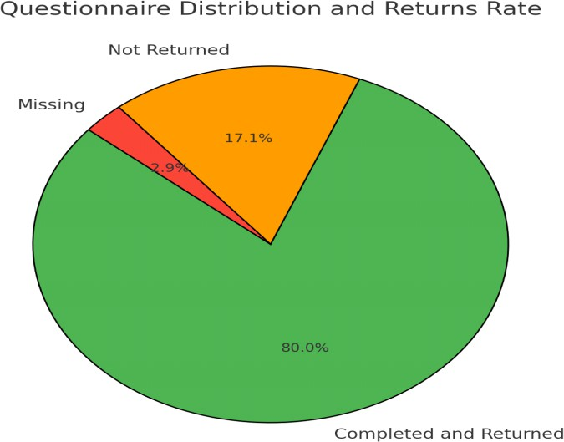

**Table 3** and **Figure 2** above indicate the return rate is 80%, indicating a strong response rate. The non-response rate (those not returned) is 17.14%, which is relatively low and might be attributed to factors like lack of time or interest from the respondents. Missing data is due to lost questionnaires or incomplete; however, this is only 2.86.

**Figure 3:** Demographic-Data of Respondents

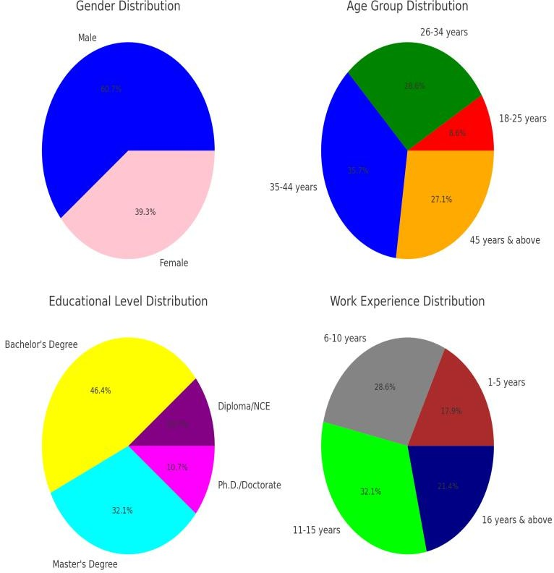

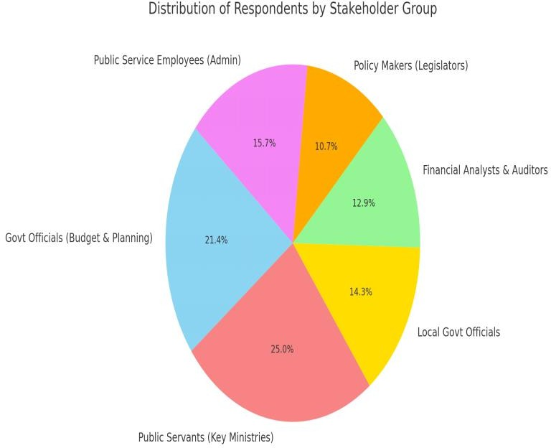

As it indicated in **Table 4** and **Figures 3** showing the Gender Distribution and the higher percentage of male respondents (60.7%) suggests a gender imbalance in budget-related roles within Cross River’s public service. The significant female representation (39.3%) indicates increasing female participation in government financial planning and decision-making.

**Table 4** and **Figure 3** also show the Age Group and it indicates that the 35–44 years age group (35.7%) represents the majority, indicating that mid-career professionals dominate budget implementation roles. The 26–34 years group (28.6%) suggests active engagement of young professionals, which is beneficial for long-term policy continuity. The low representation (8.6%) of the 18–25 age groups may indicate fewer entry-level roles in strategic planning and budgeting departments.

Further, on Educational Level **Table 4** and **Figure 3** illustrates that a majority hold a Bachelor's Degree (46.4%)**,** highlighting the relevance of academic qualifications in public financial management. The significant number of Master's holders (32.1%) suggests the need for specialized knowledge in budget implementation. The presence of Ph.D. holders (10.7%) reflects academic expertise, essential for policy research and strategic planning.

Following the report of **Table 4** and **Figure 3** also, the dominance of respondents with 11–15 years of experience (32.1%) suggests that professionals at this level play a key role in budget implementation. A significant number (28.6%) have 6–10 years of experience, indicating an experienced but adaptable

workforce. The lower percentage of 1–5 years (17.9%) suggests a need for improved recruitment strategies to attract younger professionals.

From the pie chart, and **Table 4** on the distribution of respondents across different stakeholder groups in the study on Strategic Planning and Its Effectiveness in Budget Implementation in Cross River’s Public Service is as follows: Public Servants in Key Ministries (35 respondents, 25%) is the highest representation, indicating their direct involvement in budget execution and policy implementation. Their insights are crucial for understanding the operational challenges and gaps in strategic budgeting. Government Officials in Budgeting and Planning Departments (30 respondents, 21.4%) means that these officials play a critical role in formulating and overseeing budget allocations. Their perspectives provide key information on strategic financial planning and forecasting. Local Government Officials (20 respondents, 14.3%) representing a significant portion, their feedback sheds light on budgetary control and financial resource distribution at the grassroots level. Public Service Employees in Administrative Roles (22 respondents, 15.7%) provide insights into the practical application of budgetary guidelines and financial decision-making at operational levels. Financial Analysts and Auditors (18 respondents, 12.9%) shows their role in budget monitoring and accountability makes their input valuable in evaluating financial efficiency and identifying discrepancies. Policy Makers (Legislators) (15 respondents, 10.7%) shows as decision-makers, their perspectives help in understanding how legislative oversight impacts budget performance.

### Analysis on the impact of budget allocation accuracy on the effectiveness of budget implementation

**Figure 4:** Impact of Budget Allocation Accuracy on Budget Implementation

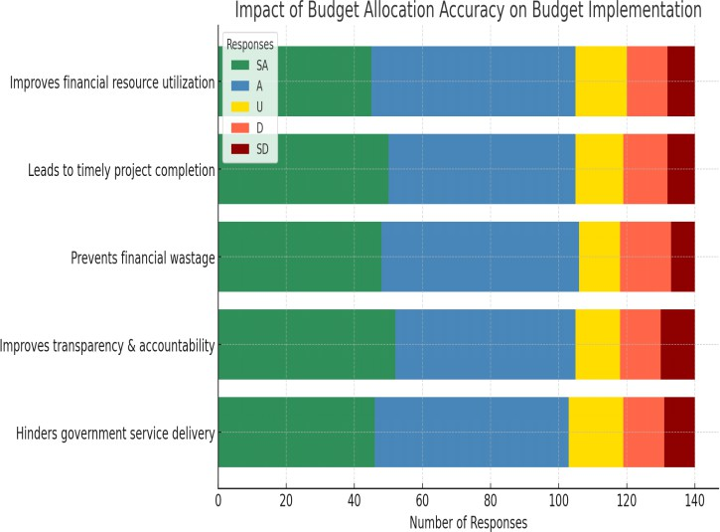

**Table 5** and **Figure 4** shows that the majority of respondents (SA: 45, A: 60) agreed that accurate budget allocation enhances financial resource utilization. This suggests that proper allocation leads to more efficient use of funds, reducing mismanagement and enhancing productivity. A significant number (SA: 50, A: 55) believe budget accuracy ensures projects are completed on schedule. Delays in budget allocation could slow down government projects, affecting service delivery and economic development. 48 respondents strongly agreed and 58 agreed that budget accuracy minimizes financial waste. This indicates that precise allocation reduces unnecessary expenditures, fostering accountability and cost-effectiveness. Majority (SA: 52, A: 53) see accurate budgeting as crucial for government transparency. This highlights the role of clear budget processes in reducing corruption and improving public trust. Fewer respondents (SA: 46, A: 57) agreed, while

16 were uncertain. While some view budgeting as restrictive, a well-implemented budget is essential for sustainable public service delivery.

The analysis confirms that budget allocation accuracy significantly impacts the effectiveness of budget implementation in Cross River State’s public service. Efficient budgeting enhances financial management, ensures timely project execution, and promotes accountability. However, challenges in budget allocation can slow down service delivery, requiring strategic improvements in financial planning.

### Analysis on relationship between financial forecasting and the effectiveness of budget implementation

**Figure 5:** Relationship between financial forecasting and budget implementation

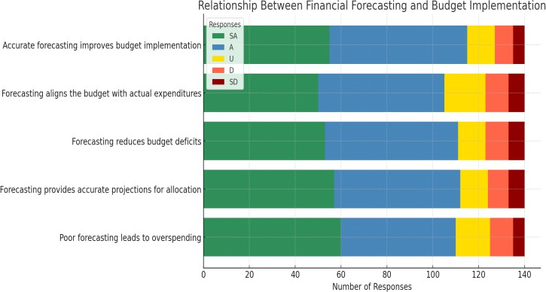

**Table 6** and **Figure 5** shows that 55 respondents

(39.3%) strongly agreed**,** and 60 respondents (42.9%) agreed that accurate financial forecasting improves budget implementation. Accurate financial forecasting plays a crucial role in ensuring that the budget aligns

with the financial resources available, enhancing effective allocation and reducing financial discrepancies.

55 respondents (39.3%) agreed and 50 respondents (35.7%) strongly agreed that forecasting guarantees that the budget and actual spending are in line. This illustrates the importance of accurate financial forecasts in upholding practical budgeting strategies that take into consideration actual spending needs and prevent deficits.

53 respondents (37.9%) strongly agreed with the statement that effective forecasting reduces budget deficits, whereas 58 respondents (41.4%) agreed. A robust forecasting process reduces the danger of overspending, maintains financial balance, and encourages fiscal discipline. Forecasting provides accurate predictions for resource allocation, according to 55 respondents (39.3%) who agreed and 57 respondents (40.7%) who strongly agreed. Accurate forecasting is crucial for effective resource allocation and management, which ensures on-time project completion and enough funding for public services. Sixty respondents (42.9%) strongly agreed and fifty respondents (35.7%) agreed that poor financial forecasting leads to excessive expenditure. This highlights how poor forecasting may lead to financial inefficiencies, resource misallocation, and the need for corrective action.

Most responders concur that precise financial forecasting is essential to implementing a budget successfully. Effective forecasting lowers budget deficits, guarantees alignment with actual spending, and encourages more efficient use of available resources. However, poor forecasting is associated with excessive spending and ineffective budget management, which can cause financial instability and impede the accomplishment of strategic objectives. The study emphasizes the need for improving forecasting practices in the public sector to ensure effective budget implementation, reduce wastage, and promote sustainable public service delivery.

### Analysis on the extent budgetary control influences the effectiveness of budget implementation

**Figure 6:** Budgetary control influences the budget implementation

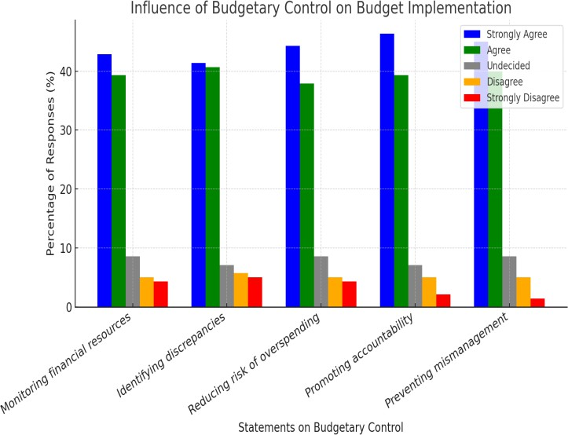

**Table 7** and **Figure 6** shows that Monitoring Financial Resources (42.9% SA, 39.3% A) showing a majority (82.2%) strongly agree or agree that budgetary control helps in tracking financial resources. THIS suggests that effective financial monitoring is perceived as a crucial factor in budget success. Identifying Discrepancies (41.4% SA, 40.7% A) meaning around 82.1% believe budgetary control plays a major role in detecting inconsistencies. This indicates a strong reliance on control mechanisms to improve budget accuracy. Reducing Risk of Overspending (44.3% SA, 37.9% A) and with 82.2% in agreement, budgetary control is seen as vital for preventing excessive expenditure. This highlights its importance in ensuring financial discipline. Promoting Accountability (46.4% SA, 39.3% A), signifies that the highest agreement (85.7%) emphasizes that budgetary control enhances accountability. This reinforces the need for strict financial oversight in public service. Preventing Mismanagement (45.0% SA, 40.0% A) illustrating that 85% of respondents affirm that budgetary control prevents financial mismanagement. This indicates that strong budget controls lead to better resource utilization.

High levels of agreement across all statements suggest that budgetary control is widely recognized as a determinant of budget effectiveness. The minimal percentage of disagreement (≤5.7%) implies strong consensus among stakeholders. Policymakers should strengthen budgetary control measures to maximize financial efficiency and accountability in public service.

### Testing the Hypotheses

**H₀:** Budget allocation accuracy, financial forecasting and budgetary control has no significant influence on the effectiveness of budget implementation in the Public Service of Cross River State.

### Analysis of the Model Summary and Hypothesis Testing of Multiple Regressions

Given the information from **Table 8** of the tested multiple regression results. The 0.998 R value shows a very high degree of beneficial association between the independent variables (Budget Allocation Accuracy, Financial Forecasting, and Budgetary Control) and the dependent variable (Effectiveness of Budget Implementation). This suggests that the model fits the data very well. The R Square value of 0.996 implies that 99.6% of the variance in the effectiveness of budget implementation (EBI) is explained by the independent variables (BAA, FF, BC). This is an excellent fit for the model, indicating that the predictors (Budget Allocation Accuracy, Financial Forecasting, and Budgetary Control) have a very strong influence on the effectiveness of budget implementation. The R-squared value is adjusted for the number of predictors in the model by the Adjusted R Square value of 0.995. It remains quite near to the R-square, demonstrating the model's resilience and proving that adding the predictors does not result in overfitting the model.

How far the observed values typically deviate from the regression line is estimated by the Standard Error of the Estimate. The value of 1.651 suggests a small level of error, indicating that the model is quite accurate in predicting the effectiveness of budget implementation.

R Square Change**:** 0.996; This shows that the inclusion of the predictors (BAA, FF, BC) accounts for a sizable amount of the dependent variable's volatility, Effectiveness of Budget Implementation (EBI). The high value suggests that these factors are essential in assessing the efficacy of budget implementation. The F Change value of 1675.729 is extremely large, indicating

that the model with the predictors (BAA, FF, and BC) is statistically significant. This means that the regression model is significantly better at explaining the dependent variable (EBI) than a model with no predictors. Degrees of Freedom (df1, df2**)**: (3, 21) and the degrees of freedom indicate the number of independent variables in the model and the sample size. With df1 **=** 3 and df2 **=** 21, A suitable sample size serves as the foundation for the model, guaranteeing statistical validity.

The model is extremely significant, as indicated by the Sig. F Change value of 0.000. A statistically significant link between the predictors (BAA, FF, and BC) and the dependent variable (EBI) is shown by a p-value of less than 0.05. Thus, we reject the null hypothesis (H₀)**,** which posited that budget allocation accuracy, financial forecasting, and budgetary control have no significant influence on the effectiveness of budget implementation**.** The residuals (errors) are tested for autocorrelation using the Durbin-Watson statistic. There is no discernible autocorrelation when the value is around 2. A 2.258 score indicates that there is no problematic autocorrelation in the model, confirming that the residuals are independent.

Therefore, the hypothesis (H₀)**,** which suggested that budget allocation accuracy, financial forecasting, and financial control have no discernible impact on how well the budget is implemented in Cross River State's public service, it is denied. With 99.6% of the variance in budget implementation effectiveness explained by the independent variables, the regression model demonstrates a very strong link between them and the dependent variable. Budget allocation accuracy (BAA), financial forecasting (FF), and budgetary control (BC) are all statistically significant predictors of the effectiveness of budget implementation in Cross River State, making them key factors for improving budget performance in public service.

# SWOT Analysis

The **Table 10** summarizes the strengths**,** weaknesses**,** opportunities, and threats based on the study's findings:

|  |  |  |
| --- | --- | --- |
| **SWOT**  **Factor** | **Description** | **Implications** |
| **Strengths** | - **High predictive power (R² = 0.996)**, indicating that budget allocation accuracy, financial forecasting, and  budgetary control have a strong influence on budget effectiveness. | - Strong correlation between predictors and the effectiveness of budget implementation. |
| - **Significant impact of predictors (BAA, FF, BC)** on  budget performance. | - Reliable tools to guide decision-  making and resource allocation. |
| - **Efficient resource allocation** ensuring projects are  completed on time and resources are optimally used. | - Enhanced fiscal responsibility and  better financial management. |
| - **Clear policy foundation** suggesting improvements can  be made in budgeting systems. | - Can inform future policy decisions to  enhance budgeting systems. |
| **Weaknesses** | - **Resistance to change** from public service departments  accustomed to existing budgeting processes. | - Potential hindrance to adopting more  efficient systems. |
| - **Limited training on financial forecasting and control mechanisms** may reduce effectiveness. | - Need for more capacity-building  initiatives in budgeting and financial management. |
| - **Dependence on historical data** for forecasting may lead to inaccuracies if future conditions change. | - Risk of inaccurate forecasting if not  properly adjusted for future economic conditions. |
| - **Overemphasis on control at the expense of innovation**  in budgeting processes. | - Balancing control with flexibility for  innovative solutions. |
| **Opportunities** | - **Improving budgeting frameworks** and enhancing financial management systems for better alignment. | - Upgrading existing systems can improve the efficiency of budget  implementation. |
| - **Integration of advanced technologies** (e.g., data  analytics, AI) for forecasting and control. | - Can lead to more accurate, responsive,  and efficient budgeting processes. |
| - **Strengthening capacity building and training**  **programs** for employees involved in budgeting and financial forecasting. | - Improves efficiency and reduces errors in financial decision-making. |
| - **Improved government accountability and**  **transparency** through effective budgetary controls. | - Increases public trust and ensures  proper financial oversight. |
| **Threats** | - **Political interference** in budget allocation may distort forecasting and control mechanisms. | - May undermine financial forecasting accuracy and lead to inefficient budget implementation. |
| - **Economic volatility** or **unforeseen crises** (e.g., pandemics) may disrupt financial forecasting and budget  allocation. | - Need to account for economic shifts and plan for contingencies in  forecasting. |
| - **Inconsistent enforcement of budgetary controls** across different government agencies. | - Could reduce the overall effectiveness of budget implementation across public  services. |
| - **Resource constraints** may limit investment in training and technological upgrades. | - Financial constraints could delay the implementation of improvements in  budget systems. |

**Source:** Author’s adoption, 2025

### Implications of the Findings

**Table 11** provides an overview of how the study's findings may affect different stakeholders, especially those engaged in Nigerian public sector governance.

|  |  |
| --- | --- |
| **Stakeholder** | **Implications of the Findings** |
| Government Officials in Budgeting & Planning Departments | The findings demonstrate how important accurate financial forecasting, budgetary management, and budgetary allocation are to improving budget performance. A more effective use of public monies might result from the implementation of more  comprehensive strategic planning. |
| Public Servants in Key Ministries | By ensuring that resources are distributed in line with actual needs, strategic planning and forecasting may reduce waste and improve service performance. More transparency  and accountability result from effective budgetary restraints. |
| Local Government Officials | Improved budgeting and financial forecasting methods may lead to more successful local planning, ensuring that community projects are funded and executed effectively while  adhering to local objectives. |
| Financial Analysts and Auditors | Budgetary controls and financial forecasts are essential for tracking the performance of the public sector. The study emphasises the function of auditing in reducing irregularities  and guaranteeing openness in the implementation of budgets. |
| Policy Makers (Legislators) | The results offer compelling proof that legislative supervision of financial operations is necessary. Given the enormous impact that accurate forecasting and budget allocation  have, authorities ought to support changes that improve these procedures. |
| Public Service Employees (Administrative Roles) | The study emphasises how important it is to have a clear budgeting method. Effective budgeting ensures that resources are managed effectively and projects are sufficiently  funded for public employees in administrative positions. |
| Nigerian Government | The findings highlight the necessity of reforming the public sector's budgeting and strategic planning procedures. Nigeria would be able to enhance service delivery, lower  budget deficits, and promote economic growth by fortifying its financial forecasting and management systems. |
| General Public | Better budget execution, which is fuelled by strategic planning and precise budgetary  forecasts, will strengthen social services, amenities and the provision of public services generally, increasing public confidence in government. |

**Source:** Author’s adoption, 2025

## CONCLUSION AND RECOMMENDATIONS

### Conclusion

The research shows that accurate budget allocation, budgetary oversight, and financial forecasting have a major impact on how well the Cross River State Public Service implements its budget. The results show that effective resource allocation, reducing financial waste, and improving accountability in the public sector all depend on robust strategic planning and forecasting systems. The result of the research provides compelling evidence that implementing a more structured and open budgeting strategy will enhance governance and have a favourable effect on Nigeria's economic growth by enhancing the performance of the public service.

### Recommendations

1. The administration of Cross River State and Nigeria government as a whole has been performing frequent audits and reviews of budget distribution. By ensuring that money are given in line with

genuine demands, this will prevent financial mismanagement and increase resource utilisation.

1. The government should prioritise training programs for key workers on accurate forecasting methodologies and invest in cutting-edge forecasting tools and technology to enhance budget planning and prevent disparities between the projected and actual expenditures.
2. Strengthening budgetary control procedures is necessary to guarantee that budgets are implemented correctly. This can possibly be accomplished by establishing straightforward oversight mechanisms, making sure that fund are spent responsibly, and implementing stricter monitoring procedures. Reviews and performance assessments should be carried out on a regular basis to pinpoint areas that require improvement in budget implementation.

## REFERENCES

Abbo, B. J. (2024). Developing effective budgeting and forecasting techniques. *Research Invention Journal of Current Research in Humanities and Social Sciences*, *3*(1), 71–75.

Abdikani, A. A., & Ouma, C.A. (2024). Influence of budgetary allocation on performance of projects within non-governmental organizations in Mogadishu, Somalia. *The University Journal, 6*(1), 105-115.

Abubakar, U. I., & Hassan, I. (2017). Theoretical perspectives of management and their application in Abubakar Rimi Television, Kano State, Nigeria. *IOSR Journal of Humanities and Social Science*, 22 (11): 18-28. doi: 10.9790/0837-2211081828

Adekunle, W., Bekoe, W., Badmus, S., Anagun, M., Alimi, W. (2022). Nexus Between Fiscal Discipline and The Budget Process In Africa: Evidence From Nigeria. *Theor. Pract. Res. Econom. Fields*, 2(12), 131.

https://doi.org/10.14505/tpref.v12.2(24).06

Ahwera, S. (2021). *Participatory budgeting, internal controls, and service delivery performance in selected public health facilities: A case of Wakiso District* (Unpublished doctoral dissertation). Makerere University.

Alford, J. & Greve, C. (2017). *Strategy in the Public andPrivate Sectors: Similarities, Differences and Changes. Adm. Sci, 7, 35.* [*https://doi.org/10.3390/*](https://doi.org/10.3390/) *admsci7040035*

Alvarez, C., Adhikari, P., & Mejía, A. (2021). Management accounting practices and efficiency in a Colombian multi-utility conglomerate. *Journal of Accounting & Economics Education (JAEE)*, *5*(11), 714–734. [https://doi.org/ 10.1108/](https://doi.org/%2010.1108/%20jaee-02-2020-0045) [jaee-02-2020-0045](https://doi.org/%2010.1108/%20jaee-02-2020-0045)

Ama, O., Tyungu, A., Udende, W., & Tiza, M. T. (2023). Enhancing procurement efficiency through strategic budgeting: A case study of Benue State Ministries, Departments, and Agencies (MDAs). *Global Journal of Engineering and Technology Advances, 16*(03), 070–081.

Anderfuhren-Biget, S., Varone, F., & Giauque, D. (2014). Policy environment and public service

motivation. *Public Administration, 92*(4), 807–

825. https://doi.org/10.1111/padm.12026

Ariyo-Edu, A. A., & Woli-Jomh, I. A. (2024). Budgeting and budgetary control and public sector performance: A study of public sector in Kwara State, Nigeria. *Fuoye Journal of Finance and Contemporary Issues, 6*(1), 15–30.

Asomba, I. U., Ezema, C. C., & Igbodiegwu, C. G. (2023). Performance budget and effective public expenditure management in Nigeria: The nexus. *Nigerian Journal of Social Development*, *11*(2), 137–144. [https://www.arabianjbmr.com](https://www.arabianjbmr.com/)

BalaSeshan, P. & Kotturi, J. (2020). Development of product assembly instructional video for training purpose*. Journal of Physics: Conference Series. 1716. 012027. 10.1088/1742-6596/1716/1/*

*012027.*

Bryson, J. M., Crosby, B.C., & Bryson, J. K. (2009). Understanding strategic planning and the formulation and implementation of strategic plans as a way of knowing: The contributions of actor- network theory. *International Public Management Journal*, 12(2), 172-207.

Bryson, J. M., Crosby, B. C., & Stone, M. M. (2015). Designing and implementing cross‐sector collaborations: Needed and challenging. *Public administration review*, *75*(5), 647-663.doi: 10.1111/puar.12432

Bryson, J. M. (2010). The future of public and nonprofit strategic planning in the United States. *Public Administration Review*, 70 (S1), S255-S267

Bryson, J. M. (2015). Strategic planning for public and nonprofit organizations. In J. D. Wright (Ed.), *International encyclopedia of the social and behavioral sciences* (2nd ed., Vol. 23, pp. 515– 521). Elsevier.

Bryson, J. M. (2018). *Strategic planning for public and nonprofit organization* (5th ed.).Hoboken, NJ: John Wiley

Burger, P., & Hawkesworth, I. (2013). Capital budgeting and procurement practices. *OECD Journal on Budgeting,* 13(1), 57–104. <https://doi.org/10.1787/> budget-13-5k3w580lh1q7

Chan, H., & Chen, J. (2014). Truthful multi-unit procurements with budgets. (pp. 89–105). <https://doi.org/10.1007/978-3-319-13129-0_7>

Cheruiyot, S. K., Kihara, P. M., & Senaji, T. A. (2018). Factors influencing strategic plan implementation in non-governmental organizations in Nairobi County, Kenya. *The Strategic Journal of Business Change Managemen*t, *5 (3), 999 - 1013.*

Elbanna, S., Andrews, R. & Pollanen, R. (2016). Strategic planning and implementation success in public service organizations: Evidence from Canada. *Public Management Review, 1(1), 10.1080/14719037.2015.1051576.*

Gürel, E. (2017). SWOT Analysis: A theoretical review.

*Journal of International Social Research. 1(1), 12.*

*10. 994-1006. 10.17719/jisr.2017.1832*

Handayani, K. S., Sinarwati, N. K., & Rahmawati, P. I. (2022). The effect of budget planning, budget implementation, and human resource competencies on budget realization at Ganesha University of Education. *International Journal of Social Science and Business*, *6*(3), 438–445. <https://doi.org/10.23887/ijssb.v6i3.44152>

Hessami, Z. (2014). Political corruption, public procurement, and budget composition: Theory and evidence from OECD countries. *European Journal of Political Economy*, 34, 372–389. https://doi.org/10.1016/j.ejpoleco.2014.02.005

Imende, M., Olel, M. & Gogo, D. (2020). Influence of resources on implementation of strategic plans in public secondary schools in Kakamega County, Kenya. *International Journal of Scientific and Research Publications (IJSRP).* 10. 667-675.

Kabeyi, M. (2019). Organizational strategic planning, implementation and evaluation with analysis of challenges and benefits for profit and non-profit organizations. *International Journal of Applied Research and Studies. 5. 27-32. 10.22271/allresearch.2019.v5.i6a.5870*

Kwon, H., & Kang, C. (2018). Improving project budget estimation accuracy and precision by analyzing reserves for both identified and unidentified risks. *Project Management Journal,50*(1), 86-100.

Lambe, I.B., Lawal, M. & Okoli, T. (2015). A systematic review of budgeting and budgetary control in government owned organizations. *Research Journal of Finance and Accounting*, 6(6), 1-11.

Makhado, R. (2016). Role of public accounts committees in enhancing oversight and accountability by the state-owned enterprises in South Africa. *African Politics & Policy. 2(1), 1-10.*

Matebese-Notshulwana, K & Lebakeng, T. (2019). Constraints and prospects for legislative oversight in emerging African democracies: The case of South Africa*. 10.1007/978-3-319-93509-6_10.*

Mattes, R. & Mozaffar, S. (2016). Legislatures and democratic development in Africa. *African Studies Review. 59(1), 201-215. 10.1017/asr.2016.83.*

Merriam-Webster. (2019, August 21). *Public service*. Merriam-Webster. https://www.merriam- webster.com/dictionary/public%20service

Moore, P. O., Onuora, J. K. J., & Ujam, O. J. (2024). *Budgetary implementation and performance of the public sector. IIARD International Journal of Economics and Business Management, 10*(7), 249–264.

Moretti, D., Downes, R., & Nicol, S. (2017). Budgeting and performance in the European Union. *OECD Journal on Budgeting*, *17*(1), 1–68.

Mwise, M. A., Cherono, V., & Mbithi, M. (2024). Influence of budgeting role on the implementation of strategic plans in the Nairobi City County Government, Kenya. *EPRA International Journal of Multidisciplinary Research (IJMR)*, *10*(6), 398–

412. <https://doi.org/10.36713/epra17191>

Nwaorgu, I., & Alozie, C. E. (2017). Budget evaluation and government performance: A case of the Nigerian economy. *Journal of Economics, Management and Trade*, *20*(1), 1–17. https://doi.org/10.9734/JEMT/2017/34646

Nwiado, D., & Deekor, L. (2020). Medium term expenditure framework (MTEF): A panacea for public expenditure management (PEM) in Nigeria? *Business Management Studies (BMS)*, *4*(6), 1. <https://doi.org/10.11114/bms.v6i4.5078>

Odalonu, H. B. (2020). The role of legislature in promoting good governance in Nigeria. In E. O. Aninwene, K. N. Anoke, B. H. Odalonu, & B. A. Chia (Eds.), *Studies in social sciences and humanities* (pp. 140–160). Book Works Publisher.

Odewole, P., Salawu, R. (2020). The implementation of budget reform and the level of compliance among the public sector entities in Nigeria.***Journal of***

*Business Administration Research (JBAR)*, 2(9),

19. https://doi.org/10.5430/jbar.v9n2p19

Omosidi, A. S., Oguntunde, D. A., Oluwalola, F. K., & Ajao, R. L. (2019). Budget implementation strategies and organisational effectiveness in colleges of education in Nigeria. *Makerere Journal of Higher Education, 10*(2), 119–131. <https://doi.org/10.4314/majohe.v10i2.9>

Om-Prakash, K., Abdullah, K. A., Daoud, R., Moulana, Y., & Matriano, M. T. (2024). The budgeting and forecasting analysis and the impact on company financial performance and strategic decision- making: A case of National Finance, Oman. *Global Scientific Journal*, *12*(6), 2133–2157. Retrieved from

[https://www.globalscientificjournal.com](https://www.globalscientificjournal.com/)

Otieno, B. O. (2019). *Effect of budgetary control uses on financial performance of public universities in Nairobi County, Kenya* (Unpublished doctoral dissertation). Maseno University.

Peng, Q., Huang, X., Jin, N., Li, H., & Liu, H. (2022).

The impact of deviation from budgetary expenditure on the efficiency of local government expenditure: An empirical analysis based on provincial data from China 2007 to 2019. *International Journal of Economics, Finance and Management Sciences*, *10*(5), 280–287. https://doi.org/10.11648/j.ijefm.20221005.16

Pirkkalainen, H., Salo, M., Tarafdar, M. & Makkonen,

M. (2019). Deliberate or Instinctive? Proactive and Reactive Coping for Technostress. *Journal of Management Information Systems. 1(1), 10. 10.1080/07421222.2019.1661092.*

Pollack, P. K. M., Rutkow, L., & McGinty, E. E. (2018). The importance of policy change for addressing public health problems. *Public Health Reports (Washington, D.C.: 1974)*, *133*(1_suppl), 9S–14S. <https://doi.org/10.1177/00333549181330S103>

Romenska, K., Chentsov, V., Rozhko, O., & Uspalenko,

V. (2023). *Budget planning with the development of the budget process in Ukraine*. University of Ukraine Printing Press.

Ruru, N., Kalangi, L., & Budiarso, N. S. (2017). Analisis penerapan alokasi dana desa (ADD) dalam upaya meningkatkan pembangunan desa: Studi kasus

pada Desa Suwaan, Kecamatan Kalawat, Kabupaten Minahasa. *Going Concern: Jurnal Riset Akuntansi*, *12*(01), 83–90. <https://doi.org/10.32400/gc.12.01.17140.2017>

Rusu, C., & Halmajan, H. (2023). Strategic alignment through budgeting and forecasting: A framework for organizational success. *Journal of Business Strategy*, 44(2), 123-139.

https://[www.emerald.com/insight/content/doi/10.1](http://www.emerald.com/insight/content/doi/10.1) 108/JBS-01-2023-0001/full/html

Sadq, Z., Sardar, B., Faeq, D. & Mohammed, H. (2020). The Effect of Strategic Planning on Entrepreneurship Strategy Requirements (The Case of Private Hospitals in Iraqi Erbil City). *International Journal of Multicultural and Multireligious Understanding. 7. 147-164.*

Steven, N. (2024). Budgeting vs. financial forecasting: What's the difference? *Investopedia*. [https://www.investopedia.com/ask/answers/04221](https://www.investopedia.com/ask/answers/042215/whats-difference-between-budgeting-and-financial-forecasting.asp) [5/whats-difference-between-budgeting-and-](https://www.investopedia.com/ask/answers/042215/whats-difference-between-budgeting-and-financial-forecasting.asp) [financial-forecasting.asp](https://www.investopedia.com/ask/answers/042215/whats-difference-between-budgeting-and-financial-forecasting.asp)

Takeuchi, R., Wang AC & Farh JL (2020). Asian conceptualization of leadership: Progresses and challenges. *Annual Review of Organizational Psychology and Organizational Behavior, 7(1), 233–256.*

Tapanainen, T., Dao, K., Nguyen, H., Nguyen, H., Dang, N & Nguyen, N. (2021). Impact of Dynamic Capabilities and Firm Characteristics on the Firm Performance of Vietnamese Small and Medium - sized Retail Enterprises. *International Journal of Management and Enterprise Development. 21 (1).10.1504/IJMED.2022.10044558.*

Tobbala, S. (2019). Towards a decentralized governance system in Egypt. *Journal of Public Policy and Administration, 4(1), 13 – 32.*

Umar, A., Muhammad, N., & Hassan, I. (2020). Strategic planning process and organizational performance in Nigerian public sector: A review of literature. *International Journal of Academic Research in Business and Social Sciences, 10*(7), 367–382. https://doi.org/10.6007/IJARBSS/v10- i7/3858417

Vogel, J., Steinberger, J. K., O'Neill, D. W., Lamb, W. F., & Krishnakumar, J. (2021). Socio-economic conditions for satisfying human needs at low energy use: An international analysis of social provisioning. *Global Environmental Change, 69*, 102287. <https://doi.org/> 10.1016/j.gloenvcha.

2021.102287

**APPENDICES**

**Table 1:** Summary of Number of Respondents

|  |  |
| --- | --- |
| **Stakeholder Group** | **No. of Respondents** |
| Government Officials in Budgeting and Planning Departments | 45 |
| Public Servants in Key Government Ministries | 60 |
| Local Government Officials | 30 |
| Financial Analysts and Auditors | 15 |
| Policy Makers (Legislators) | 10 |
| Public Service Employees in Administrative Roles | 150 |
| Total number of respondents | 310 |

**Source:** Field Survey, 2025

**Table 2**: Shows Description of the Variables Used in Model

|  |  |  |  |
| --- | --- | --- | --- |
| **Variable** | **Symbol** | **Description** | **Measurement** |
| Effectiveness of Budget  Implementation | EBI | Dependent variable. Measures how well the budget is executed in terms of resource  allocation, timeliness, and goal achievement. | Indicator-based, such as the accuracy of fund distribution, project execution,  and financial goal fulfillment. |
| Budget Allocation Accuracy | BAA | Independent variable. Represents how accurately funds are allocated to the planned  budget categories. | Percentage or ratio of allocated vs. actual spending in each budget  category. |
| Financial Forecasting | FF | Independent variable. Measures the accuracy and reliability of financial forecasting in  relation to actual budget implementation. | Comparison of forecasted vs. actual budgetary figures, typically in  monetary terms. |
| Budgetary Control | BC | Independent variable. Refers to the systems  and processes used to monitor, control, and adjust budget execution. | Existence and effectiveness of budget  monitoring tools, such as audits, adjustments, or reviews. |
| Intercept (Constant) | β₀ | Represents the baseline level of budget  implementation effectiveness when all independent variables are zero. | Constant term in the regression equation. |
| Coefficient for Budget Allocation Accuracy | β₁ | Measures the change in budget implementation effectiveness for each unit  change in budget allocation accuracy. | Estimated value from regression analysis that quantifies the impact of  BAA on EBI. |
| Coefficient for Financial Forecasting | β₂ | Measures the change in budget implementation effectiveness for each unit  change in financial forecasting. | Estimated value from regression analysis that quantifies the impact of  FF on EBI. |
| Coefficient for Budgetary Control | β₃ | Measures the change in budget implementation effectiveness for each unit  change in budgetary control. | Estimated value from regression analysis that quantifies the impact of  BC on EBI. |
| Error Term | ε | Represents unexplained variation or error in  the model. Indicates the effect of other unmeasured factors on budget implementation. | Residuals from the regression model,  representing factors not included in the analysis. |

**Source:** Author’s Adoption, 2025

**Table 3:** Questionnaire Distribution and Returns

|  |  |  |
| --- | --- | --- |
| **Category** | **Number** | **Percentage (%)** |
| Total Sample Size | 175 | 100% |
| Completed and Returned | 140 | 80% |
| Not Returned | 30 | 17.14% |
| Missing (if applicable) | 5 | 2.86% |
| Total number of respondents | 175 | 100% |

**Source:** Field Survey, 2025

**Table 4:** Bio-Data of Respondents (n = 140)

|  |  |  |  |
| --- | --- | --- | --- |
| **Category** | **Sub-category** | **Frequency (n)** | **Percentage (%)** |
| **Gender** | Male | 85 | 60.7% |
|  | Female | 55 | 39.3% |
| Age Group | 18 – 25 years | 12 | 8.6% |
|  | 26 – 34 years | 40 | 28.6% |
|  | 35 – 44 years | 50 | 35.7% |
|  | 45 years & above | 38 | 27.1% |
| Educational Level | Diploma/NCE | 15 | 10.7% |
|  | Bachelor's Degree | 65 | 46.4% |
|  | Master's Degree | 45 | 32.1% |
|  | Ph.D./Doctorate | 15 | 10.7% |
| Work Experience | 1 – 5 years | 25 | 17.9% |
|  | 6 – 10 years | 40 | 28.6% |
|  | 11 – 15 years | 45 | 32.1% |
|  | 16 years & above | 30 | 21.4% |
| Stakeholder Group | Government Officials in Budgeting &  Planning | 30 | 21.4% |
|  | Public Servants in Key Ministries | 35 | 25.0% |
|  | Local Government Officials | 20 | 14.3% |
|  | Financial Analysts and Auditors | 18 | 12.9% |
|  | Policy Makers (Legislators) | 15 | 10.7% |
|  | Public Service Employees (Administrative) | 22 | 15.7% |

**Source:** Field Survey, 2025

**Table 5:** Responses on the Impact of Budget Allocation Accuracy on Budget Implementation

|  |  |  |  |  |  |  |  |
| --- | --- | --- | --- | --- | --- | --- | --- |
| S/N | Statement | SA  (n,%) | A  (n,%) | U  (n,%) | D  (n,%) | SD  (n,%) | Total  (n,%) |
| 1 | Budget allocation accuracy improves  financial resource utilization. | 45  (32.1%) | 60  (42.9%) | 15  (10.7%) | 12  (8.6%) | 8  (5.7%) | 140  (100%) |
| 2 | Proper allocation of budget leads to timely project completion. | 50  (35.7%) | 55  (39.3%) | 14  (10.0%) | 13  (9.3%) | 8  (5.7%) | 140  (100%) |
| 3 | Inaccurate budget allocation results in  financial wastage. | 48  (34.3%) | 58  (41.4%) | 12  (8.6%) | 15  (10.7%) | 7  (5.0%) | 140  (100%) |
| 4 | Effective budget allocation improves  transparency and accountability. | 52  (37.1%) | 53  (37.9%) | 13  (9.3%) | 12  (8.6%) | 10  (7.1%) | 140  (100%) |
| 5 | Poor budget allocation hinders government  service delivery. | 46  (32.9%) | 57  (40.7%) | 16  (11.4%) | 12  (8.6%) | 9  (6.4%) | 140  (100%) |

**Source:** Field Survey, 2025

**Table 6**: Responses on the Relationship Between Financial Forecasting and Budget Implementation

|  |  |  |  |  |  |  |  |
| --- | --- | --- | --- | --- | --- | --- | --- |
| S/N | Statement | SA  (n,%) | A  (n,%) | U  (n,%) | D (n,%) | SD  (n,%) | Total  (n,%) |
| 1 | Accurate financial forecasting improves budget  implementation. | 55  (39.3%) | 60  (42.9%) | 12  (8.6%) | 8  (5.7%) | 5  (3.6%) | 140  (100%) |
| 2 | Financial forecasting ensures that the budget  aligns with actual expenditures. | 50  (35.7%) | 55  (39.3%) | 18  (12.9%) | 10  (7.1%) | 7  (5.0%) | 140  (100%) |
| 3 | Effective forecasting contributes to reducing  budget deficits. | 53  (37.9%) | 58  (41.4%) | 12  (8.6%) | 10  (7.1%) | 7  (5.0%) | 140  (100%) |
| 4 | Financial forecasting provides accurate  projections for resource allocation. | 57  (40.7%) | 55  (39.3%) | 12  (8.6%) | 9  (6.4%) | 7  (5.0%) | 140  (100%) |
| 5 | Poor financial forecasting leads to  overspending in the budget. | 60  (42.9%) | 50  (35.7%) | 15  (10.7%) | 10  (7.1%) | 5  (3.6%) | 140  (100%) |

**Source:** Field Survey, 2025

**Table 7:** Responses on the Influence of Budgetary Control on Budget Implementation

|  |  |  |  |  |  |  |  |
| --- | --- | --- | --- | --- | --- | --- | --- |
| S/N | Statement | SA  (n,%) | A  (n,%) | U  (n,%) | D  (n,%) | SD  (n,%) | Total  (n,%) |
| 1 | Budgetary control ensures proper monitoring of financial resources. | 60  (42.9%) | 55  (39.3%) | 12  (8.6%) | 7  (5.0%) | 6  (4.3%) | 140  (100%) |
| 2 | Budgetary control helps in identifying and  correcting budgetary discrepancies. | 58  (41.4%) | 57  (40.7%) | 10  (7.1%) | 8  (5.7%) | 7  (5.0%) | 140  (100%) |
| 3 | Effective budgetary control reduces the risk of  overspending. | 62  (44.3%) | 53  (37.9%) | 12  (8.6%) | 7  (5.0%) | 6  (4.3%) | 140  (100%) |
| 4 | Budgetary control mechanisms promote  accountability and transparency. | 65  (46.4%) | 55  (39.3%) | 10  (7.1%) | 7  (5.0%) | 3  (2.1%) | 140  (100%) |
| 5 | Poor budgetary control leads to mismanagement  and inefficiency. | 63  (45.0%) | 56  (40.0%) | 12  (8.6%) | 7  (5.0%) | 2  (1.4%) | 140  (100%) |

**Source:** Field Survey, 2025

**Table 8:** Responses on the Effect of Strategic Planning on Budget Implementation

|  |  |  |  |  |  |  |  |
| --- | --- | --- | --- | --- | --- | --- | --- |
| S/N | Statement | SA  (n,%) | A  (n,%) | U  (n,%) | D  (n,%) | SD  (n,%) | Total  (n,%) |
| 1 | Strategic planning enhances the alignment of the  budget with government priorities. | 55  (39.3%) | 60  (42.9%) | 12  (8.6%) | 8  (5.7%) | 5  (3.6%) | 140  (100%) |
| 2 | Effective strategic planning improves budget  allocation and resource distribution. | 50  (35.7%) | 58  (41.4%) | 15  (10.7%) | 9  (6.4%) | 8  (5.7%) | 140  (100%) |
| 3 | Strategic planning ensures that financial resources are allocated efficiently in accordance with  priorities. | 53  (37.9%) | 59  (42.1%) | 14  (10.0%) | 8  (5.7%) | 6  (4.3%) | 140  (100%) |
| 4 | Strategic planning contributes to reducing budget  discrepancies and improving performance. | 60  (42.9%) | 55  (39.3%) | 12  (8.6%) | 7  (5.0%) | 6  (4.3%) | 140  (100%) |
| 5 | Without strategic planning, budget  implementation would be less effective. | 62  (44.3%) | 53  (37.9%) | 10  (7.1%) | 8  (5.7%) | 7  (5.0%) | 140  (100%) |

**Source:** Field Survey, 2025

**Table 9:** Multiple regression results

**Model Summaryb**

|  |  |  |  |  |  |  |  |  |  |  |
| --- | --- | --- | --- | --- | --- | --- | --- | --- | --- | --- |
|  |  | R  Square | Adjusted R Square | Std. Error  of the Estimate | Change Statistics | | | | | Durbin- Watson |
| Model | R | R Square  Change | F  Change | df1 | df2 | Sig. F  Change |
| 1 | .998a | .996 | .995 | 1.651 | .996 | 1675.729 | 3 | 21 | .000 | 2.258 |

1. Predictors: (Constant), BC, BAA, FF
2. Dependent Variable: EBI

**Source:** SPSS Output, 2025